9th Annual ACDi NC Charity Golf Tournament

REGISTRATION & SPONSOR PACKET 2023

To Benefit

https://www.acdi.com/nc-annual-charity-golf-tournament/

Event Overview

Friday, June 2, 2023
Belmont Lake Country Club
201 Belmont Club Way
Rocky Mount, NC 27804

Registration 8am
9am Shotgun Start
Raffle & Awards ~2pm

Breakfast, Lunch & Beverages Included
$100 per person
$375 per foursome
Benefitting Charity:
Tax i.d. W-9 (EIN) # 56-0934910

Our Amazon wish list for prize donations to be used in the raffle can be found here: https://a.co/0cP8nv5

Contact Information

Contact Information
Jess Meyers (Payments/Receipts)
301-624-1646
jmeyers@acdi.com

Janice Gibson (Sponsorships/General) 301-624-1623
jgibson@acdi.com

Joyce Richardson (Sponsorships/General)
252-462-4733
jrichardson@acdi.com

Nancy Vick (Sponsorships/General)
252-462-4722
nvick@acdi.com

ACDi Charity Golf Tournament History

ACDi North Carolina will be hosting our 9th Annual Charity Golf Tournament on Friday, June 2, 2023 at Belmont Lake Golf Club. All proceeds will benefit the Boys & Girls Clubs of The Tar River Region’s Nashville Area Unit. It’s been our tradition to host charity events that benefit groups such as food banks and organizations serving women and children, such as St. Jude’s Children’s Hospital and Faith House. ACDi has raised in excess of $150,000 over the past 11 years.
The Boys & Girls Clubs of The Tar River Region has an impressive history that began over 50 years ago with the establishment of the Boys Club in Rocky Mount, NC. The organization has since grown to serve thousands of young people between the ages of 5-18 in nine locations in the Twin Counties, currently offering services in Nashville, Rocky Mount, Tarboro, Baily, Cedar Grove, Middlesex, Williford, and Spring Hope elementary schools, as well as Southern Nash Middle. The Boys & Girls Clubs of The Tar River Region provides a world-class club experience that assures success is in the reach of every club member that walks through its doors, offering all members on track to graduate from high school with a plan for the future, demonstrating good character and citizenship, and living a healthy lifestyle.
Download Credit Card Authorization Here
Download a W-9 Here

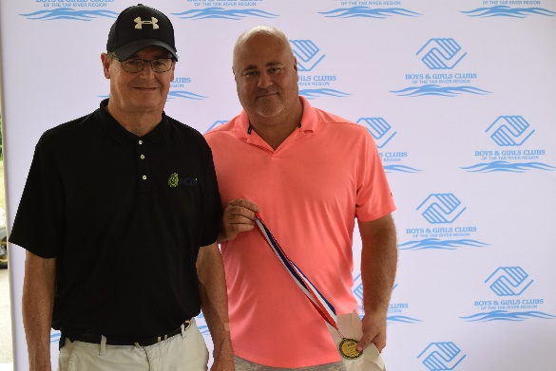
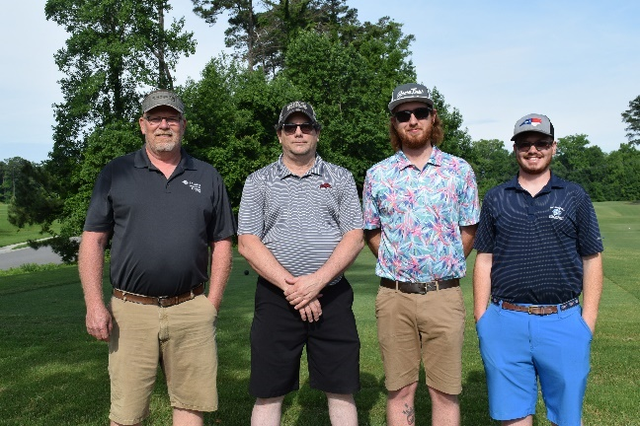
Sponsorships

Presenting Sponsor
$1000 SOLD
ONLY 1 AVAILABLE
- 1 team entry of 4 players (if you can’t fill a team, we will donate it!)
- Distribution of marketing material in golf gift bags
- Opportunity to present overview of company during shotgun start of the event
- Exclusive company logo on all promotion, including
  - Premium logo placement on golf landing page on www.acdi.com
  - Premium positioning on volunteer t-shirts
  - All social media marketing
  - All printed marketing materials, including lunch giveaway to all golfers (sponsor provided)
  - Exclusive sign at hole of your choice

Golf Ball Sponsor
$1500 SOLD
1 AVAILABLE

• Logo imprinted on sleeve of golf balls given to each player

Lunch Sponsor
$750 SOLD
1 AVAILABLE
- 2 player entry (if you can’t fill 2 spots, we will donate it!)
- Opportunity to speak at lunch prior to start of raffle
- Exclusive sign at hole of your choice
- Logo placement on golf landing page on www.acdi.com
- Distribution of marketing material in golf gift bags (limited to one-page flyer or promo item)
- Logo included on volunteer t-shirts

Breakfast Sponsor
$500 (or provide breakfast sandwiches and coffee/juice for 110 people; to be agreed upon by sponsor and ACDi)
1 AVAILABLE SOLD
- Logo placement on golf landing page on www.acdi.com
- Logo signage on breakfast table
- Exclusive sign at hole of your choice
- Distribution of marketing material in golf gift bags (limited to one-page flyer or promo item)
- Logo included on volunteer t-shirts

Hole-in-One Hole Sponsor
$750
1 AVAILABLE SOLD
- Representative from your company at the hole
- Logo placement on golf landing page on www.acdi.com
- Exclusive sign at hole
- Distribution of marketing material in golf gift bags (limited to one-page flyer or promo item)
- Logo included on volunteer t-shirts

Photo Frame Sponsor
$750 1 AVAILABLE SOLD
• Logo imprinted on foursome photo frame given to each tournament player
• Logo placement on golf landing page on www.acdi.com
• Distribution of marketing material in golf gift bags (limited to one-page flyer or promo item)

Eagle Sponsor
$500
0 5 AVAILABLE SOLD OUT
- 2 player entry
- Logo placement on golf landing page on www.acdi.com
- Exclusive sign at hole of your choice
- Distribution of marketing material in golf gift bags (limited to one-page flyer or promo item)
- Logo included on volunteer t-shirts

Birdie Sponsor
$250
4 10 AVAILABLE
- 1 player entry
- Logo placement on golf landing page on www.acdi.com
- Exclusive sign at hole of your choice
- Distribution of marketing material in golf gift bags (limited to one-page flyer or promo item)
- Logo included on volunteer t-shirts

Raffle Donation
Unlimited

Goodie Bag Donation
Unlimited
- Small giveaways (110 qty.)

Yes, please sign me up to:
☐Presenting Sponsor $1000
☐Golf Ball Sponsor $1500

☐Lunch Sponsor $750

☐Breakfast Sponsor $500 (or provide breakfast sandwiches and coffee/juice for 110 people; to be agreed upon by sponsor and ACDi)

☐Hole-in-One Hole Sponsor $750
☐Photo Frame Sponsor $750

☐Eagle Sponsor $500

☐Birdie Sponsor $250

☐Goodie Bag Donation/Raffle Donation

Name: Email:

Company Name:

Address:

City, State, Zip:

Card Number:

Expiration Date: CVV

Goodie Bag/Raffle Donation items:

Payment methods

Check *See bottom of next page for additional payment information

Golf Registration

☐$100 per person
☐$375 per foursome

Name/Company: Email Address:

Name/Company: Email Address:

Name/Company: Email Address:

Name/Company: Email Address:

Payment Methods

Check
Email forms to jmeyers@acdi.com or send via mail to ACDi, 7435 New Technology Way, Ste A, Frederick, MD 21703
Pay by Check (make check payable to ACDi, 7435 New Technology Way, Ste A, Frederick, MD 21703)
*This is a tax-deductible expense and a receipt will be provided upon request
**You can make a donation directly to Boys and Girls Club Tar River Region by check as well, and we will give it to them as part of our event

